**CIVIL AGREEMENT MANAGEMENT SYSTEM**

**UWINEZA LANDRINE**

**REG. N0: D/BIT/19/09/11555**

Under the guidance and supervision of Dr Jean Baptiste MBANZABUGABO

A Dissertation Submitted to:

University of Kigali in partial fulfillment of the requirement for the award in Bachelor’s Degree in Bachelors of Science in Information Technology (BIT) submitted to School of Computing and Information Technology.

**SEPTEMBER,2023**

DECLARATION

I, UWINEZA LANDRINE do declare that this dissertation is my own work. I have to the best of my knowledge acknowledged all authors or sources from where I got information. I further declare that this work has not been submitted in any university or institution for the award of a degree or any of its equivalents.

Signed ---------------------------------Date …………………………………….

ACKNOWLEDGEMENT

First of all, I would like to acknowledge and give thanks in very special way to my almighty God, from whom all knowledge, wisdom and understanding rightly comes special thanks to my family and my friend, for their contribution in moral and financial field supports has been of inestimable value.

I would like to thank my supervisor (**Dr Jean Baptiste MBANZABUGABO)** for his effort and intellectual support he granted me during the time of writing this report and for guidance and support during the entire course of this project. I am grateful also to all my classmates for the spirit of teamwork and friendship that they showed me.

Special thanks go to the NOTARY of GISOZI SECTOR for providing us the basic information about their working and permission to use their information which aided us to complete this idea, technical knowledge, and any supports especially my friend who tirelessly provided very special contribution relevant with my research. I would like to extend my deepest and most heartfelt gratitude.

I also thank all my faculty members for steering me through the tough as well as easy phases of the project in a result-oriented manner with concern attention.

APPROVAL

This is to acknowledge that this dissertation has been submitted with my approval.

**Name: Dr Jean Baptiste MBANZABUGABO**

Sign………………………………… Date……………………………….

TABLE OF CONTENTS

DECLARATION i

ACKNOWLEDGEMENT ii

APPROVAL iii

TABLE OF CONTENTS iv

LIST OF FIGURES viii

LIST OF TABLES ix

LIST OF ABBREVIATIONS x

ABSTRACT xi

CHAPTER 1 INTRODUCTION TO THE STUDY 1

1.0 INTRODUCTION 1

1.1 BACKGROUND OF THE STUDY 1

1.2 PROBLEM STATEMENT 3

1.3 OBJECTIVE OF STUDY 4

1.3.1 The general objective 4

1.3.2 Specific objective 4

1.4 RESEARCH QUESTIONS 4

1.5 SIGNIFICANCE OF PROJECT 4

1.5.1 Personal interest 4

1.5.2 Institutional interest 4

1.5.3 Public interest 5

1.6 SCOPE OF THE PROJECT 5

1.6.1 Time scope 5

1.6.2 Geographical scope 5

1.6.3 Content scope 5

1.7 LIMITATION OF STUDY 5

CHAPTER 2 LITERATURE REVIEW 6

2.0 INTRODUCTION 6

2.1 DEFINITION OF KEY CONCEPTS 6

2.1.1 CIVIL AGREEMENT 6

2.1.2 Web application 6

2.1.3 database 6

2.1.4 System 7

2.2 EMPIRICAL REVIEW/PAST STUDY 7

2.2.1 Civil contract in Singapore 7

2.2.2 Civil agreement in United Kingdom 8

2.3 Theoretical review 10

2.3.1 Existing system 10

2.3.2 Proposed system 10

2.4 CRITICAL REVIEW/SUMMARY GAP 11

2.5 CONCEPTUAL FRAMEWORK 11

CHAPTER 3 RESEARCH METHODOLOGY 13

3.0 INTRODUCTION 13

3.1 RESEARCH DESIGN 13

3.1.1 Software development models 13

3.2 POPULATION AND SELECTION OF SAMPLING 15

3.2.1 Population 15

3.2.2 Area of study 15

3.2.3 participants 15

3.2.4 sampling 15

3.3 TOOLS FOR DATA COLLECTION/INSTRUMENTATION 16

3.3.1 Internet research 16

3.3.2 interview 16

3.3.3 Observation 16

3.3.4 Documentation 17

3.4 Collection of data 17

3.5 Analysis of data 17

3.6 Validity and reliability 17

CHAPTER 4 SYSTEM ANALYSIS, DESIGN AND IMPLEMENTATION 18

4.0 INTRODUCTION TO THE STUDY 18

4.1 DATA ANALYSIS AND PRESENTATION 18

4.1.1 Weakness observation in the current system 18

4.2 Interpretations of findings 18

4.3 Summary of finding 18

4.4 Description of existing system 19

4.5 Description of new system 19

4.5.1 Functional requirement 20

4.5.2 Non-Functional requirement 20

4.5.3 System configuration 21

4.6 Illustration of New system/Solution: 21

4.6.1 Data Flow Diagram and processes (Context Diagram, DFD-Level 1,2, etc) 22

4.6.1.1 Context (Level 0) Diagram 22

4.6.2 Normalization 24

4.6.3 Data Dictionary 25

4.6.4 Entity Relationship Diagram 29

4.6.5 Physical Data Model 29

4.7 Architecture design of the new System 30

4.8 Implementation and coding 35

4.8.1 Introduction 35

4.8.2 Description of implementation Tools and technology 35

4.8.3 Screen Shots and Source Codes 36

4.9 Testing 40

4.9.1 Introduction 40

4.9.2 Objective of Testing 40

4.9.3 Unit testing outputs 41

4.9.4 Validation testing outputs 41

4.9.5 Integration Testing Outputs 41

4.9.6 Functional and system testing Results 42

4.9.7 Acceptance Testing Report 42

CHAPTER 5 CONCLUSIONS AND RECOMMANDATION 43

5.0 INTRODUCTION 43

5.1 Conclusion 43

5.2 Recommendation 44

BIBLIOGRAPHY 45

LIST OF FIGURES

**Figure 1:CIVIL AGREEMENT IN SINGAPORE** 9

**Figure 2:AGREEMENT IN UNITED KINGDOM** 10

**Figure 3:CONCEPTUAL FRAMEWORK** 13

**Figure 4:WATERFALL MODEL DIAGRAM** 15

**Figure 5 DFD Level 0** 23

**Figure 6 DFD Level1** 24

**Figure 7 ERD** 29

**Figure 8:physical data model** 30

**Figure 9: Login page** 30

**Figure 10:user registration page** 31

**Figure 11:user list after registration** 32

**Figure 12:civilian registration page** 33

**Figure 13:list of citizens after registration** 34

**Figure 14:create agreement page** 34

**Figure 15:list of agreement after creation** 34

**Figure 16:agreement detail** 35

LIST OF TABLES

**Table 1:Sample size** 17

**Table 2:agreement table** 26

**Table 3:Citizen table** 27

**Table 4:payment table** 27

**Table 5:users table** 28

LIST OF ABBREVIATIONS

**UOK:** University of Kigali.

**BIT:** Bachelors of Information Technology.

**IT:** Information Technology.

**CAMS**: Civil Agreement Management System

**SQL:** Structured Query Language.

**HTML**: Hypertext Markup Language.

**CSS**: Cascading Style Sheets.

**PHP:** Hypertext Preprocessor.

**RAM :** Random Access Memory

**SDLC** : Software Development Life Cycle

**XAMPP:** Extended Apache MySQL, PHP, Perl.

ABSTRACT

The project named civil agreement management System is management software that allow citizen creating and managing their agreement. This project will be developed in PHP and it will be mainly focuses on basic operation like register notary and citizen, creating agreement and making payment. To achieve my objectives, I used the techniques of interview, observation, and documentation in data collection, I used waterfall model for software development. Computerized system was developed using PHP, JavaScript, HTML, CSS and technologies was used to create front-end of the system (interfaces) and also MySQL was used to create a database as back-end of the system. This system has security components in front of username and authentication to help make boundaries in the database to secure information from unauthorized and malicious users.

# INTRODUCTION TO THE STUDY

## INTRODUCTION

This chapter is focusing on introduction of the online civil agreement background of the study, problem statement, its objective (both general and specific), research questions, and the scope of the project, interest of the project which is about personal, institutional and public interests and limitation of the project.

## BACKGROUND OF THE STUDY

Civil agreements in Rwanda are governed by the Rwandan Civil Code and other relevant laws and regulations. A civil agreement is a legally binding agreement between two or more parties, which can be individuals, companies or organizations. Civil agreements can cover a wide range of issues, such as the sale of goods, the provision of services, or the lease of property. To create a civil agreement in Rwanda, the parties must first agree on the terms of the agreement, including the subject matter, the price, and any other relevant terms and conditions. Once the terms of the agreement have been negotiated and agreed upon, the parties must sign the agreement in the presence of a notary or a lawyer. This is called "authenticating" the agreement. In Rwanda, an authenticated agreement is considered to be a public document, which means that it can be used as evidence in court if necessary. Once the agreement has been authenticated, it becomes legally binding on all parties involved, and each party must fulfil their obligations under the terms of the agreement.

If one party fails to fulfil their obligations under the agreement, the other party may have the right to seek legal remedies, such as compensation or specific performance, through the courts. It is important to note that civil agreements in Rwanda are subject to the principle of good faith, which means that the parties must act honestly and fairly towards each other in all aspects of the agreement.

In Rwanda, the law that governs the punishment of individuals who fail to fulfil a civil agreement with another party is the Law of Obligations and Contracts, which was enacted in 2018. The law provides for various remedies that may be available to the injured party, including specific performance, damages, and termination of the agreement.

Under the Law of Obligations and Contracts, if a party fails to fulfil their obligations under a civil agreement, the injured party may seek specific performance, which is an order from the court requiring the non-performing party to fulfil their obligations as specified in the agreement. If specific performance is not possible or would not adequately compensate the injured party, they may seek damages, which can include compensation for any losses or expenses incurred as a result of the breach of the agreement.

In addition to specific performance and damages, the Law of Obligations and Contracts also provides for termination of the agreement if one party fails to fulfil their obligations. The injured party may terminate the agreement and seek compensation for any losses or damages suffered as a result of the breach.

It is important to note that the specific remedies available under the Law of Obligations and Contracts may depend on the nature of the agreement and the specific terms of the contract. It is recommended to seek legal advice if you have concerns about enforcing a civil agreement in Rwanda or if you believe that another party has failed to fulfil their obligations under an agreement.

The main challenge that peoples face when making civil agreements manually in Rwanda is the limited access to legal expertise. This can make it difficult for individuals to ensure that their agreements are legally sound and enforceable, particularly if the agreement is complex and involves multiple parties or legal requirements. Additionally, manual agreements may lack standardization, be time-consuming, and have a higher risk of errors, which can lead to misunderstandings and disputes. Limited accessibility and enforceability of manual agreements can also pose significant challenges. (gazette, 2011)

the Ministry of Justice (MINIJUST) is located in capital city of Rwanda called Kigali, district of Gasabo in Kacyiru plays a significant role in relation to civil agreements. MINIJUST is the government ministry responsible for overseeing the legal system, ensuring access to justice, and promoting the rule of law. While the primary role of MINIJUST is to provide legal and judicial services, it indirectly influences civil agreements in Rwanda through its various functions. Here are some ways MINIJUST can be involved: Legislation and Regulation, Legal Advice and Assistance, Mediation and Alternative Dispute Resolution, Civil Registry and Notary Services, Legal Compliance and Enforcement.

This system will allow user to create, manage and store civil agreement and also will allow user to make payment if it included will also store transaction of payment. civil agreement management system will help people to overcome the problem that the people was faced in making civil agreement will allow people which are not in the same area to make agreement and will also help people to make agreement without writing what has been agreed which this system is not secure because can cause same errors, fraud paper, loss those copies and it is difficult to make same modification and this system was also challenge to the court because court was receiving cases of people who fail to fulfil what they has been agreed so it was problem for this company to find evidence and to check if those evidence is real or fake and this system will allow court to get evidence which is secure and in easy way and will allow people to make agreement without third person as witness. Using witness was also costly because who came as witness you have to pay them. In this system they are three users: admin, notary, citizen. the admin will be the one to register notary for first time and admin will collect their information. they provided information such as names, telephone Number, email, national id, address after register notary will give them username and password. For the user who want to make agreement for first time will be registered by notary in system after that notary will send citizen username and password The user will user this user name and password for login after login they will go to home and create agreement. After complete to create other party will receive notification of the agreement if they view the agreement will require them to accept if they accept it is like signing on the agreement and the agreement will appear on the dashboard. This system will allow user to make payment if it is included in agreement.

Civil agreement management system is web application which will help people to make civil agreement in quickest and easy way and will help them to secure the storage of agreement.

## PROBLEM STATEMENT

Civil agreements are typically made through a process involving several steps. The parties involved usually engage in negotiations to establish the terms and conditions of the agreement. Once an agreement is reached, it can be formalized through a written contract or documented agreement, which is signed by the parties involved and third person as witness. This process may involve the assistance of legal professionals or notaries to ensure the legality and enforceability of the agreement. Usually, those parties end up in court because one of those party failed to fulfill what has been negotiated. The issue court was facing was that they use manually system which is hard to find records and evidence which was difficult to the resolve disputes because lack of evidence and this existing system was not accessible to the citizen because it doesn’t allow people from different locations to create agreement without physically meeting which cause them effort and consume them time.

## OBJECTIVE OF STUDY

### The general objective

The main objective of developing a system is to provide a convenient and accessible platform for individuals and organizations to create legally binding agreements without the need for physical meetings or traditional paperwork.

### Specific objective

1. To develop a user-friendly digital platform specifically designed for creating and managing civil agreements.
2. To find a perfect secured storage for civil agreements
3. To establish the way of making payment can be made online for future use.

## RESEARCH QUESTIONS

1. What type of digital platform to develop?
2. How to securely store civil agreements?
3. How the payment will be established?

## SIGNIFICANCE OF PROJECT

### Personal interest

This project will help me to acquire new knowledge, it will also help me to put into practice the knowledge and skills acquired during the university studies as we studied different modules which combined together accomplish this project.

### Institutional interest

* allowing institutions to handle multiple cases simultaneously and potentially increase their client base.
* reducing the risk of errors or missing information in agreements.
* It reduces paperwork, enhances document management, and simplifies the overall workflow.

### Public interest

* People will benefit from the ease and convenience of making civil agreements online. They can avoid the hassle of physically meeting with parties involved, saving time and effort.
* enabling people from different locations to create agreements without geographical limitations.
* ensuring that all parties have access to the agreement details.
* Online platforms can maintain digital records and evidence, making it easier to resolve disputes and enforce agreements when necessary.

## SCOPE OF THE PROJECT

### Time scope

The research, design and implementation of this project will take 3 months from May 2023 to July 2023.

### Geographical scope

Geographically the project research was conducted at in Gisozi/Gasabo/Kigali-Rwanda. It is where I visited the office of the notary to understand their work.

### Content scope

This application will help people to overcame problem of creating civil agreement which was required all parties to meet physically and the time the court was taking to find evidence. This system will allow user to create, manage and storing civil agreement and secure storage of civil agreement and make payment if it is included.

## LIMITATION OF STUDY

This researcher project might be limited according to few information given by notary who knows how the schedule management operate day to day can affect the result of my research and the system also, there might be some of sector skipped involuntary by the lack of information and proper guidance.

# LITERATURE REVIEW

## INTRODUCTION

Through this chapter, we will reveal more about the new system which is ‘CIVIL AGREEMENT MANAGEMENT SYSTEM ‘will have a good understanding of the existing system as a pivot for the conception of the new system. The analysis of the existing system will help us to identify the limits of the current system and the margin for error and to value the importance of the authorized and organizational changes planned for the new system. This chapter covers the theoretic concepts that will be used in research, and also describe in a clear way how this new system will be implemented to solve problems and issues of the current system as well as the proposed solutions.

## DEFINITION OF KEY CONCEPTS

### CIVIL AGREEMENT

A civil agreement is a legal agreement between two parties resolving a dispute and is commonly handled through the civil court system. Also known as a settlement, a civil agreement is usually the final agreement after mediation takes place. Civil agreements take place between two business entities, individuals or a combination of both. (upcounsel, n.d.)

### Web application

 web application (or web app) is application software that runs on a web server, unlike computer-based software programs that are run locally on the operating system (OS) of the device. Web applications are accessed by the user through a web browser with an active network connection. These applications are programmed using a client–server model—the user ("client") is provided services through an off-site server that is hosted by a third-party. Examples of commonly-used web applications include: web-mail, online retail sales, online banking, and online auctions. (ern, 2019)

### database

A database is an organized collection of structured information, or data, typically stored electronically in a computer system. A database is usually controlled by a [database management system (DBMS)](https://www.oracle.com/database/what-is-database/#WhatIsDBMS). Together, the data and the DBMS, along with the applications that are associated with them, are referred to as a database system, often shortened to just database. (derclaye, 2005)

### System

A system is a set of elements or components that interact to accomplish goals, the elements themselves and the relationships among them determine how the system works. Systems have inputs, processing mechanisms, outputs and feedbacks (Clark, 1967,April)

## EMPIRICAL REVIEW/PAST STUDY

### Civil contract in Singapore

In Singapore, civil agreements are governed by the law of contract, which is based on the common law system. Civil agreements are legally binding documents that define the terms and conditions of a relationship or transaction between two or more parties. The agreement must be in writing and signed by the parties involved. According to the Ministry of Law of Singapore, the requirements for a valid contract include an offer, acceptance, consideration, and an intention to create legal relations. The contract must also be entered into freely and voluntarily, without any undue influence or coercion. To create a civil agreement in Singapore, the parties involved typically consult with a lawyer or legal professional to draft the agreement. The agreement must be written in clear and concise language and must include all of the relevant terms and conditions agreed upon by the parties.

Once the agreement is drafted, the parties may sign it in the presence of a witness. Alternatively, electronic signatures may be used in certain circumstances, such as when the parties are unable to meet in person. The electronic signatures must comply with the Electronic Transactions Act and must be legally valid.

In the event that one party breaches the terms of the civil agreement, the other party may seek legal remedies such as damages, specific performance, or termination of the agreement. (lee, 2019)



**Figure 1:CIVIL AGREEMENT IN SINGAPORE**

### Civil agreement in United Kingdom

In the United Kingdom, civil agreements are legally binding contracts between two or more parties that outline the terms and conditions of a specific agreement or transaction. Examples of civil agreements include employment contracts, lease agreements, and purchase agreements.

To be considered a valid civil agreement in the United Kingdom, the following conditions must be met:

1. The parties involved must have legal capacity to enter into an agreement. This means they must be of legal age and have the mental capacity to understand the terms and consequences of the agreement.

2. The agreement must have a lawful purpose. It cannot be for an illegal or immoral purpose.

3. The agreement must be based on a mutual exchange of consideration, which refers to the exchange of something of value between the parties. For example, in a purchase agreement, the consideration would be the item being purchased and the money being exchanged.

Civil agreements in the United Kingdom can be made in writing, verbally, or implied through the actions of the parties involved. However, some agreements, such as those related to property and land, must be in writing and signed by all parties involved.

If a party breaches a civil agreement in the United Kingdom, the other party may have the right to take legal action to seek compensation or enforce the terms of the agreement.



**Figure 2:AGREEMENT IN UNITED KINGDOM**

**Steps of making civil agreement in United Kingdom**

The steps involved in making a civil agreement in the United Kingdom can vary depending on the nature of the agreement, but generally include the following:

1. Negotiation: The parties involved in the agreement will negotiate the terms and conditions of the agreement.

2. Drafting: Once the negotiations are complete, the terms of the agreement will be written down in a legal document.

3. Review: Each party will review the document to ensure that the terms and conditions are acceptable to them.

4. Signing: The parties involved in the agreement will sign the document to indicate their acceptance of the terms.

5. Exchange: Once all parties have signed the document, copies will be exchanged so that each party has a copy of the agreement.

6. Registration: Depending on the nature of the agreement, it may need to be registered with a relevant authority or governing body.

7. Enforcement: If there is a breach of the agreement, the parties involved may need to take legal action to enforce the terms of the agreement. (kingdom, 2020)

## Theoretical review

### Existing system

Civil agreements are typically made through a process involving several steps. The parties involved usually engage in negotiations to establish the terms and conditions of the agreement. Once an agreement is reached, it can be formalized through a written contract or documented agreement, which is signed by the parties involved and third person as witness. This process may involve the assistance of legal professionals or notaries to ensure the legality and enforceability of the agreement. So, in this system sometimes those parties end up in court because they fail to fulfil what has been negotiated. court was facing issue of find records and evidence which can be used to resolve those conflict which consume them time and also for citizen require parties to create agreement using physically meeting which was consuming time and effort.

### Proposed system

In this proposed system will help user to create, manage and store civil agreement easily and quickly.it is difficult for two parties involves in agreement to make it without physical meeting. This system will help to overcome this problem by making civil agreement without physical meeting. Here before making civil agreement user will be required to go to the nearest office of notary to register him/her in system in order to get access in system after that user will login in system and create agreement and after finishing to create it this user will send to other party. If this party accept this agreement, it will be like signing to the agreement. Notary can add, view citizen detail and view agreement detail. This system will also allow those parties to make payment and store transactions of how payment was made. The objective of this system is to make agreement without physical meeting and will also store those records of agreement for future when those parties fail to fulfil what has been agreed will be used as evidence which will be easier for court to resolve those disputes and will also allow citizen to make agreement without those witness. Proposed system is accessed by three entities namely, Admin, notary and User. Admin can perform task such as manage and access to the notary detail and can viewing user detail. User can perform task such as create, send, accept and viewing agreement.

## CRITICAL REVIEW/SUMMARY GAP

The problem found in existing systems are:

* The existing system was hard for court to find records and evidence which was difficult to resolve those disputes and it consume them time.
* This existing system was taking citizen effort, time and it was costly because it was required them to create agreement using physically meeting.
* The existing system was requiring third person as witness which is costly because you pay them for signing you as witness in agreement.

**Proposed solution**

* Propose system will allow parties involved in agreement to create agreement without physical meeting.
* Proposed system will maintain digital records and evidence which will be easier to resolve those conflict.
* In proposed system there will be no witness which will be needed to sign.
* Proposed system will allow user to make payment using system if it needed.

## CONCEPTUAL FRAMEWORK

A conceptual framework includes one or more formal theories (in part or whole) as well as other concepts and empirical findings from the literature. It is used to show relationships among these ideas and how they relate to the research study. The users for the proposed system are: Admin, notary, Citizen.

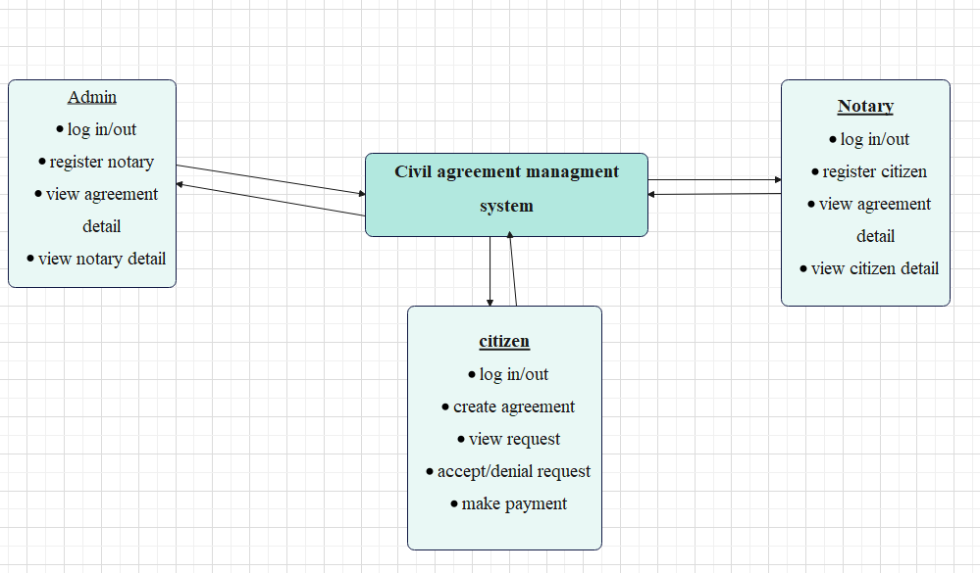

**Figure 3:CONCEPTUAL FRAMEWORK**

# RESEARCH METHODOLOGY

## INTRODUCTION

This chapter illustrate the procedures used by the researchers to achieve the objectives of this study. It presents an overview of how the research was conducted, including who were the participants, the design of the study, what the participants did, and what measures were used.

## RESEARCH DESIGN

The research design refers to the overall strategy that you choose to integrate the different components of the study in a coherent and logical way, thereby, ensuring you will effectively address the research problem; it constitutes the blueprint for the collection, measurement, and analysis of data (Akhtar, 2016).

### ****Software development models****

**Software development models** are a collection of techniques and organizational systems for creating computer software. Software Development Life Cycle*(*SDLC) model describes all of the processes in a software development project. These frameworks include program development as well as the tools required to help the development process. (Burback, 1998)

#### Waterfall model

The Waterfall Model was the first Process Model to be introduced. It is also referred to as a **linear-sequential life cycle model**. It is very simple to understand and use. In a waterfall model, each phase must be completed before the next phase can begin and there is no overlapping in the phases.

The Waterfall model is the earliest SDLC approach that was used for software development.

The waterfall Model illustrates the software development process in a linear sequential flow. This means that any phase in the development process begins only if the previous phase is complete. In this waterfall model, the phases do not overlap. the process involves moving down through the linear development stages in order: analysis, design, development, testing, deployment, and maintenance. Every stage is well-defined with specific deliverables and milestone (Model, W., s2015).

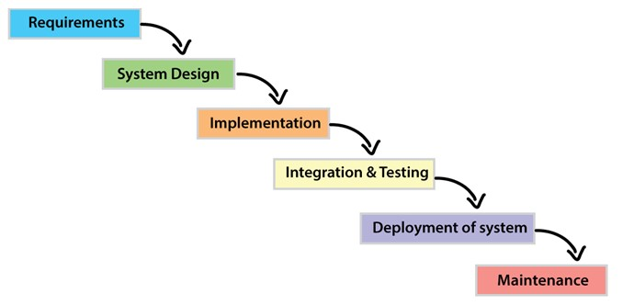

**Figure 4:WATERFALL MODEL DIAGRAM**

The sequential phases in Waterfall model are:

* **Requirement Gathering and analysis**: All possible requirements of the system to be developed are captured in this phase and documented in a requirement specification document.
* **System Design**: The requirement specifications from first phase are studied in this phase and the system design is prepared. This system design helps in specifying hardware and system requirements and helps in defining the overall system architecture.
* **Implementation**: With inputs from the system design, the system is first developed in small programs called units, which are integrated in the next phase. Each unit is developed and tested for its functionality, which is referred to as Unit Testing.
* **Integration and Testing**: All the units developed in the implementation phase are integrated into a system after testing of each unit. Post integration the entire system is tested for any faults and failures.
* **Deployment of system**: Once the functional and non-functional testing is done; the product is deployed in the customer environment or released into the market.
* **Maintenance**: There are some issues which come up in the client environment. To fix those issues, patches are released. Also, to enhance the product some better versions are released. Maintenance is done to deliver these changes in the customer environment.

All these phases are cascaded to each other in which progress is seen as flowing steadily downwards (like a waterfall) through the phases. The next phase is started only after the defined set of goals are achieved for previous phase and it is signed off, so the name "Waterfall Model". In this model, phases do not overlap. (Limited, 2019)

## POPULATION AND SELECTION OF SAMPLING

### Population

The target population of people who end up in court because they failful what they have been negotiated are 20 per months.

### Area of study

The research will be conducted at GISOZI SECTOR; it will work GISOZI which consists of two cells: MUSEZERO and RUHANGO

### participants

1. **Admin**

The IT worker who will control or manage system.

1. **Citizen**

People who will use system to create agreement.

1. **notary**

The official worker of government who will register citizen.

### sampling

Sampling is the selection of a subset of the population of interest in a research study. In the vast majority of research endeavors, the participation of the entire population is not possible, so a small group is relied upon for data collection. Sampling from population is often more practical and allows data to be collected faster and at lower cost than attempting to reach every member in population.

By sample size, we understand a group of subjects that are selected from the general population and are considered as representative of the real population for that specific study. The calculations of sample size will be determined by the following formula:

**Sampler size, n = N / (1 + Ne2)**

Where N, is total population and e, is the error expected to have in percentage.

|  |  |  |
| --- | --- | --- |
| **Respondents** | **Population** | **Sample size(n) for e=0.1** |
| **Citizen** | 15 | 13 |
| **Notary** | 5 | 5 |
| **Total** | 20 | 18 |

**Table 1:Sample size**

According to Slain, has mentioned that if population is approximately equal size, it could be good to use population instead of using sample size. As research I choose to use sample size instead of population.

## TOOLS FOR DATA COLLECTION/INSTRUMENTATION

Tools used for collecting information are:

### Internet research

**Internet research** is the practice of using [Internet](https://en.wikipedia.org/wiki/Internet) information, especially free information on the [World Wide Web](https://en.wikipedia.org/wiki/World_Wide_Web), or Internet-based resources (like Internet [discussion forum](https://en.wikipedia.org/wiki/Discussion_forum)) in research. Through searches on the Internet, [pages](https://en.wikipedia.org/wiki/Web_page) with some relation to a give topic can be visited and read, or be quickly found and gathered. (wikipedia, 2023)

### interview

An interview is a face-to-face conversation between two individuals with the sole purpose of collecting relevant information to satisfy a research purpose. Interviews are of different types namely; [Structured, Semi-structured](https://www.formpl.us/blog/structured-interview), and [unstructured](https://www.formpl.us/blog/unstructured-interview) with each having a slight variation from the other (fox, 2009).

### Observation

This is a data collection method by which information on a phenomenon is gathered through observation. The nature of the observation could be accomplished either as a complete observer, an observer as a participant, a participant as an observer, or as a complete participant. This method is a key base for formulating a hypothesis (Angrosino m. , 2007).

### Documentation

documentation is referring to a wide range of written, physical, and visual materials, including what other authors may term artifacts. documentation is a method used to obtain data and information in the form of books, archives, documents, writing numbers, and pictures in the form of reports and information that can support the research (angrosino, 2007).

## Collection of data

In collection of data, I choose Internet research to get direct information about how the civil agreement done and Also Interview by asking some people face to face about the problem people face after doing those agreement on to get addition of information about my proposal topic.

## Analysis of data

Data analysis is the process of collecting, modeling, and analyzing data using various statistical and logical methods and techniques. (ashirwadam, 2014)

## Validity and reliability

Reliability and validity are concepts used to evaluate the quality of research. They indicate how well a method, technique or test measure something. Reliability is about the consistency of a measure (quality of being trustworthy or of performing consistently well), and validity is about the accuracy of a measure (quality of being logically).

I declare that system will be validity based on quality of being truth and reason while system also will be trustworthy to any participant and performing consistently well.

# SYSTEM ANALYSIS, DESIGN AND IMPLEMENTATION

## INTRODUCTION TO THE STUDY

This chapter includes introduction to the study, system study, system analysis, system design, system implementation, system testing and validations.

## DATA ANALYSIS AND PRESENTATION

Data presentation is a process of comparing two or more data sets with visual aids, such as graphs. Using a graph, you can represent how the information relates to other data. This process follows data analysis and helps organize information by visualizing and putting it into a more readable format.

### Weakness observation in the current system

Generally, according to how civil agreement was done in manually they take time to find those records of agreement which is used in court as evidence.

## Interpretations of findings

Interpreting your findings is about seeing whether what you found confirms or does not confirm the findings of previous studies in your literature review. Your findings may also offer novel insights or information (Tom 2021).

Generally civil agreement management system can be more usefully and helpfully because it will be more easily for government to solve conflict the people face when they fail to full their negotiation it will be more easily to solve those conflict because they have evidence.

Yeah, they are some information that is confirmed because I visit office of notary at physical place, they gave me some information detail.

## Summary of finding

A summary of findings table presents the key information about the most important outcomes of a treatment, including the best effect estimate and the certainty of the evidence for each outcome.

## Description of existing system

Civil agreements are typically made through a process involving several steps. The parties involved usually engage in negotiations to establish the terms and conditions of the agreement. Once an agreement is reached, it can be formalized through a written contract or documented agreement, which is signed by the parties involved and third person as witness. This process may involve the assistance of legal professionals or notaries to ensure the legality and enforceability of the agreement. So, in this system sometimes those parties end up in court because they fail to fulfil what has been negotiated. court was facing issue of find records and evidence which can be used to resolve those conflict which consume them time and also for citizen require parties to create agreement using physically meeting which was consuming time and effort.

## Description of new system

In this proposed system will help user to create, manage and store civil agreement easily and quickly.it is difficult for two parties involves in agreement to make it without physical meeting. This system will help to overcome this problem by making civil agreement without physical. Here before making civil agreement user will be required to go to the nearest notary to register them in system in order to get access in system after that user will login in system and create agreement and after finishing to create it this user will send to other party. If this party accept this agreement, it will be like signing to the agreement. notary can view citizen detail and agreement detail. This system will also allow those parties to make payment and store transactions of how payment was made. The objective of this system is to make agreement without physical meeting and will also store those records of agreement for future when those parties fail to fulfil what has been agreed will be used as evidence which will be easier for court to resolve those disputes and will also allow citizen to make agreement without those witness. Proposed system is accessed by three entities namely, Admin, notary and User. Admin can perform task such as manage and access to the notary detail and can viewing user detail. User can perform task such as create, send, accept and viewing agreement.

**Proposed technology of the system**

### Functional requirement

Function requirement define the capabilities and function that a system must be able to perform successfully. The functional requirement of this system include.

1. The System will allow citizen to create agreement
2. The system will allow the admin to register notary
3. The system will allow the admin to view agreement detail
4. The system will allow admin to remove citizen
5. The system will allow the admin to view citizen detail

### Non-Functional requirement

Non-functional requirements cover all the remaining requirements which are not covered by the functional requirements. The specify criteria that judge the operation of system, rather than specific behaviors, for example: “modified data in a database should be update for all users accessing it within 2 seconds.”

Some typical non-functional requirements are:

1. **Performance:** for example, Response time, tough put, utilization, static volumetric
2. **Scalability:** is the property of a system to handle a growing amount of work by adding resources to the system. However, if all packages had to first pass through a single warehouse for sorting, the system would not be scalable, because one warehouse can handle only a limited number of packages.
3. **Capacity:** the maximum amount that something can contain.
4. **Availability:** the degree to which a system, subsystem or equipment is in a specified operable and committable state at the start of a mission, when the mission is called for at unknown, i.e., a random, time.
5. **Reliability:** the quality of being trustworthy or of performing consistently well.
6. **Maintainability:** maintainability is the case with which a product can be maintained in order to: correct defects or their cause, repair or replace faulty or worm-out components without having to replace.
7. **Security:** security is freedom from, or resilience against, potential harm caused by other. Beneficiaries of security may be of person and social groups, objects and institution, ecosystem or any other entity or phenomenon vulnerable to unwanted change by its environment.
8. **Usability:** usability is the ease of use and learn ability of a human-made object such as a tool or device. In software engineering, usability is the degree to which software can be used by specified consumers to achieve quantified objectives with effectiveness, efficiency, and satisfaction in a quantified context of use.

### System configuration

System configurations are the configuration that a system must have in order for a hardware or software application to run smoothly and efficiently. Failure to meet these requirements can result in installation problem or performance problems.

#### Hardware specification

1. **Hard disk:** This system will be installed in a computer that has at least 10GB of free space before installation and 100 GB on hard disk after installation.
2. **Processor:** Inter(R) Core (TM) Intel Pentium CPU G4400 @ 3.30GHz (4CPUs), -3.31GHz.
3. **Memory (RAM):** This system will be installed in a computer that has at least 2GB of RAM.
4. **External hard disk:** This system will be carried on a flash disk that has at least 4GB of free space.

#### Software specification

* **Operating system:** window 7,8 and 10
* **Language:** Php, Laravel flamework, html, bootstrap and my SQL

## Illustration of New system/Solution:

The proposed solution is to develop a digital system which is a software application which avoids more manual hours that need to spend in record keeping and generating reports. This application keeps the data in a centralized way which is available to all the users simultaneously. It is very easy to manage historical data in database.

### Data Flow Diagram and processes (Context Diagram, DFD-Level 1,2, etc)

A data flow diagram (DFD) maps out the flow of information for any process or system.it uses defined symbols like rectangles, circles and arrows, plus short text labels, to show data inputs, outputs, storage points and the routes between each destination (lucidchart 2022).

#### **Context (Level 0) Diagram**

A data flow diagram (DFD) illustrates how data is processed by a system in terms of inputs and outputs. As its name indicates its focus is on the flow of information, where data comes from, where it goes and how it gets stored.

A data flow diagram (DFD) illustrates how data is processed by a system in terms of inputs and outputs. As its name indicates its focus is on the flow of information, where data comes from, where it goes and how it gets stored.

Context diagram also known as Level 0, is a top-level data flow diagram. It only contains one process node (“Process 0”) that generalizes the function of the entire system in relationship to external entities.

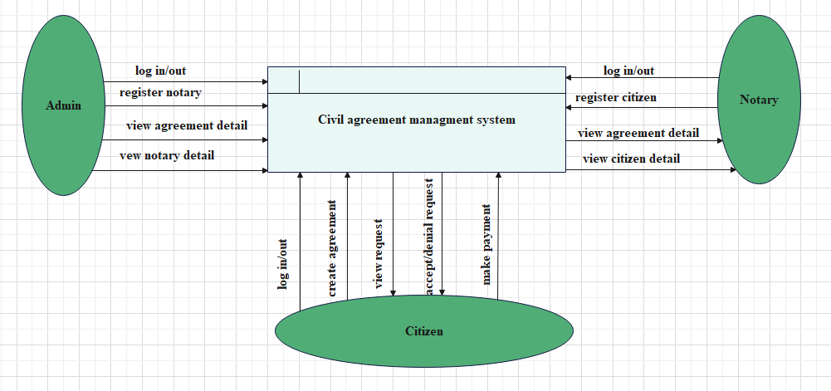

**Figure 5 DFD Level 0**

#### Data Flow Diagram (Level 1)

This context-level DFD is next "exploded", to produce a Level 0 DFD that shows some of the detail of the system being modelled. The Level 0 DFD shows how the system is divided into sub-systems (processes).

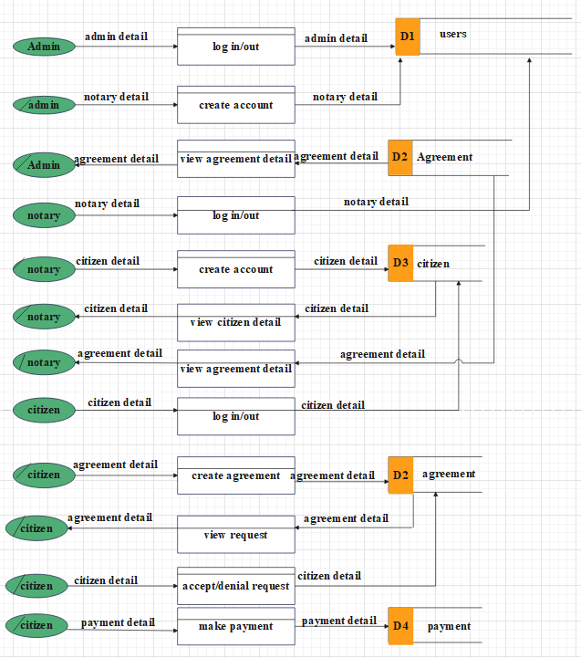

**Figure 6 DFD Level1**

### Normalization

Normalization is the process of organizing data to minimize redundancy. Normalization usually involves dividing a database into two tables and defining relationships between the tables. The objective is to isolate data so that additions, additions, deletions, and modifications of a field can be made in just one table and then propagated through the rest of the database via the defined relationship.

There are three main normal forms, each with increasing levels of normalization:

**FIRST NORMAL FORM (1NF):** each field in a table contains different information. For example, in an employee list each table would contain only one birth date field.

**SECOND NORMAL FORM (2NF):** each field in a table that is not a determiner of the contents of another field must itself be a function of the other fields in the table.

**THIRD NORMAL FORM (3NF):**  no duplicate information is permitted. So, for example, if two tables both require a birthday date field, the birthday date information would be separated into a separate table, and the two other tables would then access the birthday date information via an index field in the birthday date table. Any change to a birthday date would automatically be reflected in all tables that link to the birthday date table.

There are additional normalization levels, such as Boyce Cod Normal Form (BCNF), fourth normal form (4NF) and fifth normal form (5NF). While normalization makes databases more efficient to maintain, they can also make more complex because data is separated into so many different tables.

### Data Dictionary

A data dictionary contains metadata i.e. data about the database. The data dictionary is very important as it contains information such as what is in the database, who is allowed to access it, where is the database physically stored etc. The customers of the database normally don't interact with the data dictionary; it is only handled by the database administrators.

|  |  |  |  |
| --- | --- | --- | --- |
| **Field name** | **Data type** | **Constraints** | **Description** |
| Agreement_id | Char (36) | Not null | Table agreement identification field |
| Category | varchar (255) | Not null | Table category field |
| Description | Text | Not null | Table description field |
| Amount | Varchar (255) | Not null | Table amount of money field |
| party One | int (20) | Not null | Table party one field |
| party Two | int (20) | Not null | Table party two field |
| Status | Enum('pending', 'accepted', 'rejected', 'completed') | Not null | Table status field |
| accepted Date | varchar (255) | Not null | Table date agreement accepted field |
| rejected Date | varchar (255) | Not null | Table date agreement rejected field |
| completed Date | varchar (255) | Not null | Table date agreement completed field |
| Duration | varchar (255) | Not null | Table duration field |
| whoToPay | Enum ('me', 'other') | Not null | Table who to pay in agreement field |
| created by | bigint(20) | Not null | Table agreement created by field |
| created at | timestamp | Not null | Table date and time agreement created field |
| updated at | timestamp | Not null | Table date and time agreement updated field |

**Table 2:agreement table**

|  |  |  |  |
| --- | --- | --- | --- |
| **Field name** | **Data type** | **Constraints** | **Description** |
| id *(Primary)* | int (20) | Not null | Table citizen identification field |
| Name | varchar (255) | Not null | Table citizen name field |
| Phone | char (10) | Not null | Table citizen phone number field |
| Email | varchar (255) | Not null | Table citizen email field |
| national_id | char (16) | Not null | Table citizen national identification field |
| national_id_image | varchar (255) | Not null | Table citizen national identification image field |
| Password | varchar (255) | Not null | Table citizen password field |
| Status | Enum('1', '2', '3') | Not null | Table citizen status field |

**Table 3:Citizen table**

|  |  |  |  |
| --- | --- | --- | --- |
| **Field name** | **Data type** | **Constraints** | **Description** |
| id *(Primary)* | char (36) | Not null | Table payment identification field |
| agreement_id | Char (36) | Not null | Table agreement identification field |
| Type | Enum ('deposit', 'withdrawal') | Not null | Table payment type (deposit or withdrawal) field |
| Amount | varchar (255) | Not null | Table amount of payment field |
| Status | varchar (255) | Not null | Table payment status |
| transaction Reference | varchar (255) | Not null | Table transaction reference field |

**Table 4:payment table**

|  |  |  |  |
| --- | --- | --- | --- |
| **Field name** | **Data type** | **Constraints** | **Description** |
| id *(Primary)* | Int (20) | Not null | Table user identification field |
| Name | varchar (255) | Not null | Table user names field |
| Phone | char (10) | Not null | Table user phone number field |
| Email | varchar (255) | Not null | Table user email field |
| Password | varchar (255) | Not null | Table user password field |
| Role | Enum ('admin', 'judge') | Not null | Table user role field |
| Status | Enum ('1', '2') | Not null | Table user status field |

**Table 5:users table**

### Entity Relationship Diagram

Entity Relationship Diagrams are a major data-modeling tool and will help organize the data in your project into entities and define the relationships between the entities. This process has proved to enable the analyst to produce a good database structure so that the data can be stored and retrieved in a most efficient manner.

By using a graphical format, it may help communication about the design between the designer and the user and the designer and the people who will implement it.

An ERD typically consists of four different graphical components:

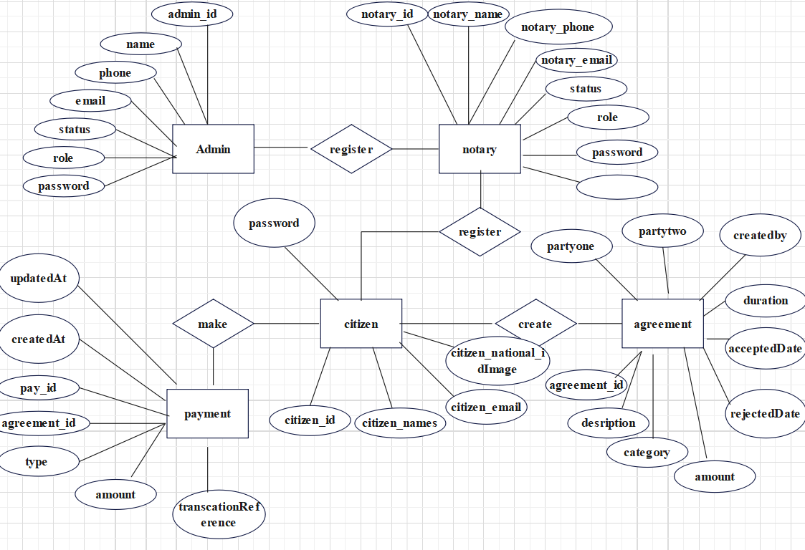

**Figure 7 ERD**

### Physical Data Model

A database schema is a way to logically group objects such as tables, views, stored procedures etc… Think of a schema as a container of objects. You can assign user login permissions to a single schema so that the user can only access the objects they are authorized to access. Schemas can be created and altered in a database, and users can be granted access to a schema. A schema can be owned by any user.

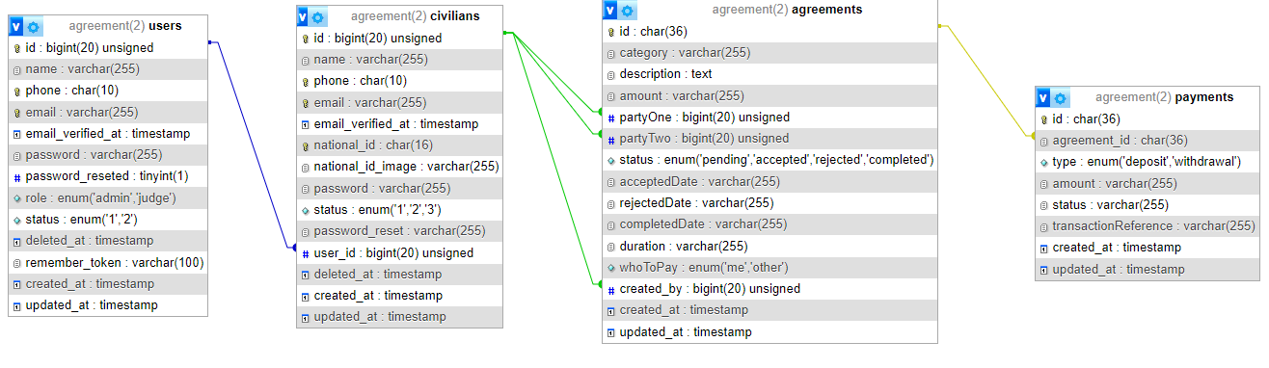

**Figure 8:physical data model**

## Architecture design of the new System

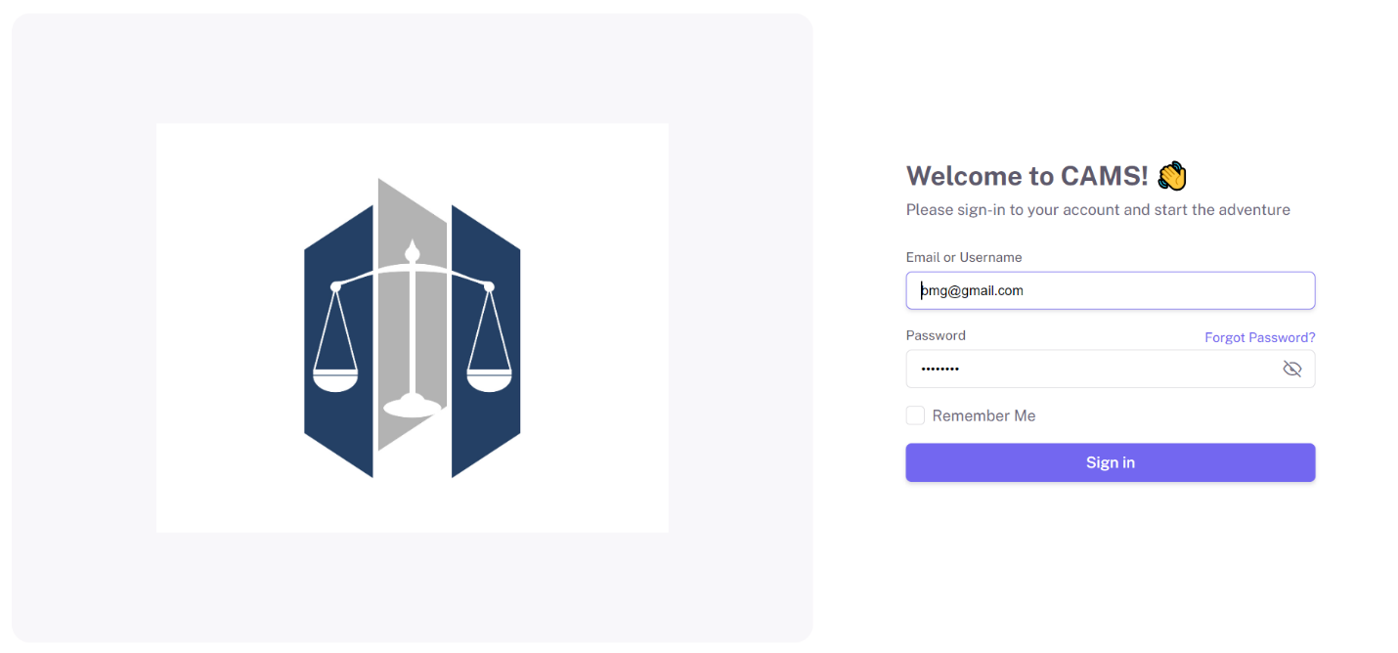

**Figure 9: Login page**

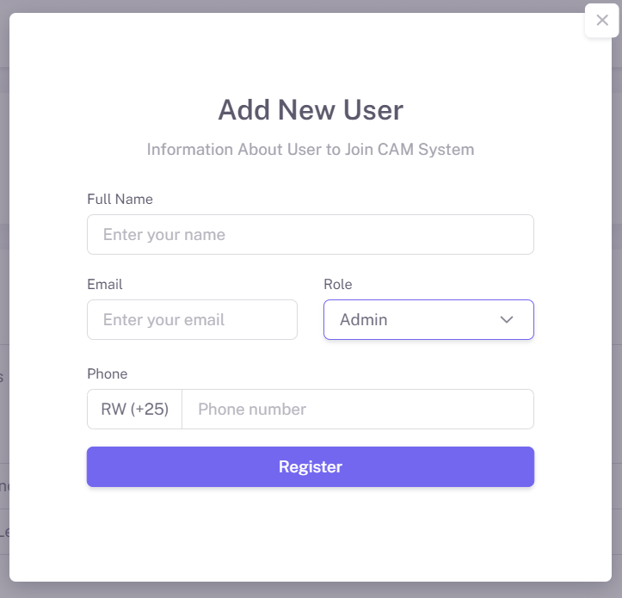

**Figure 10:user registration page**

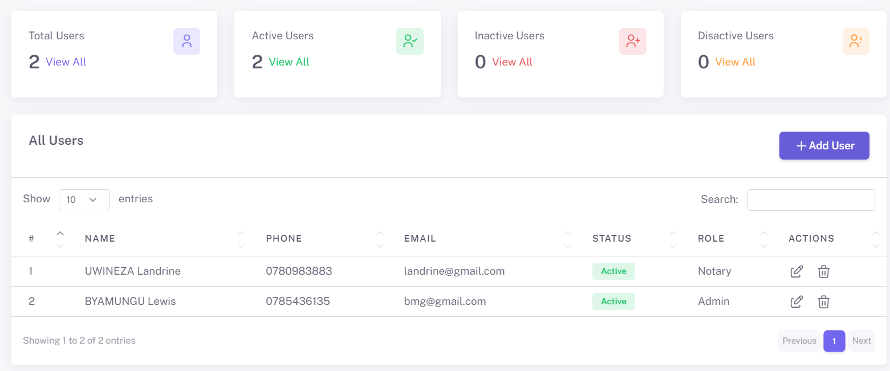

**Figure 11:user list after registration**

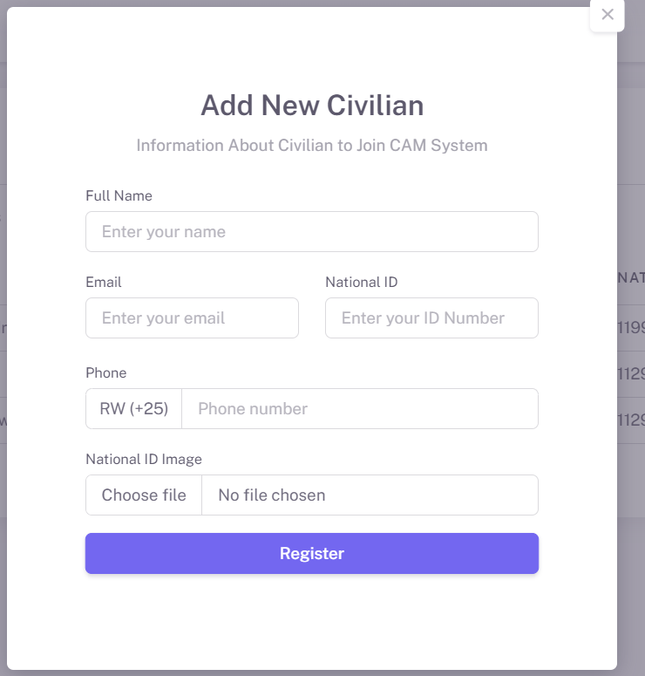

**Figure 12:civilian registration page**

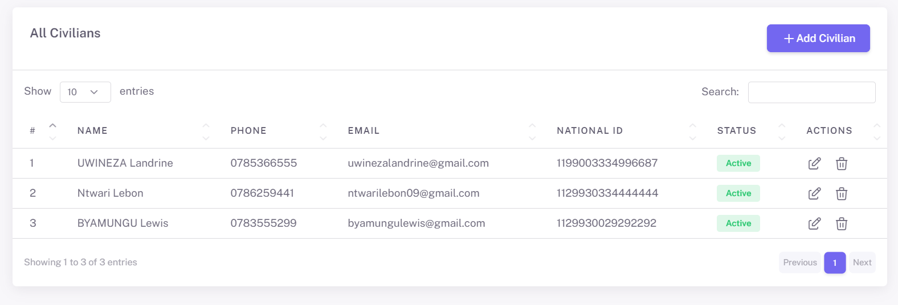

**Figure 13:list of citizens after registration**

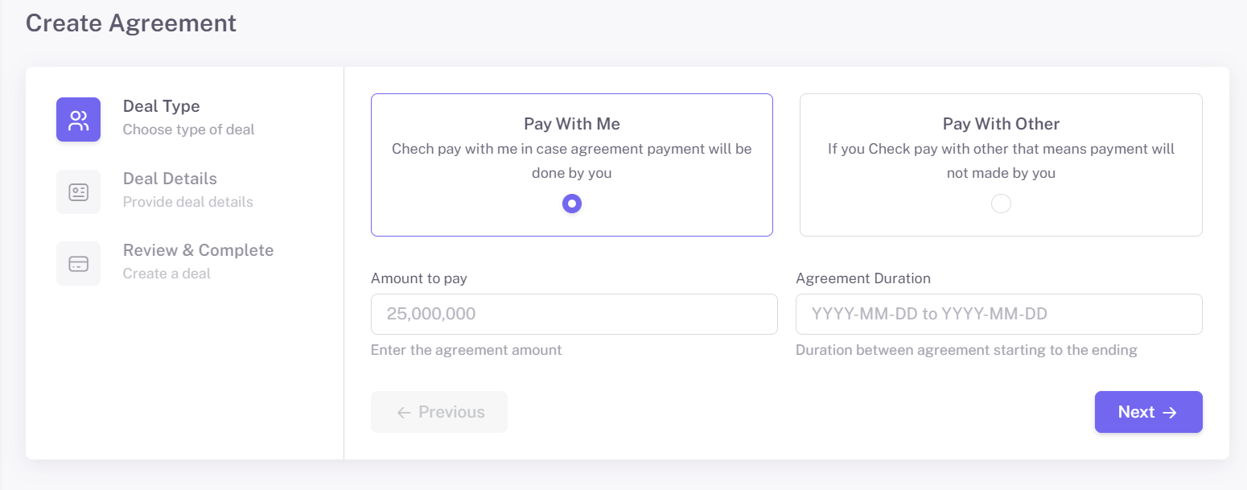

**Figure 14:create agreement page**

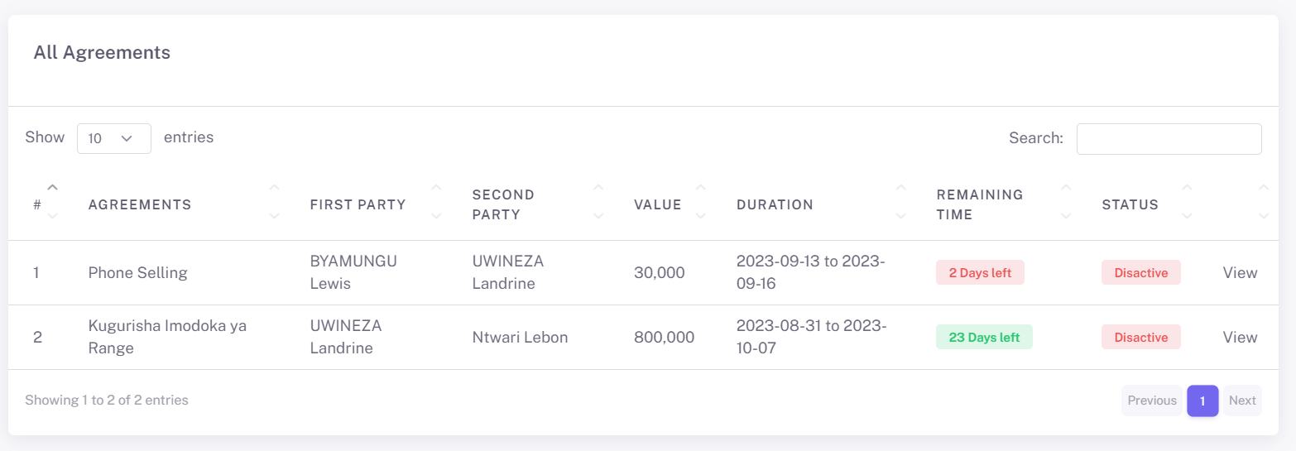

**Figure 15:list of agreement after creation**

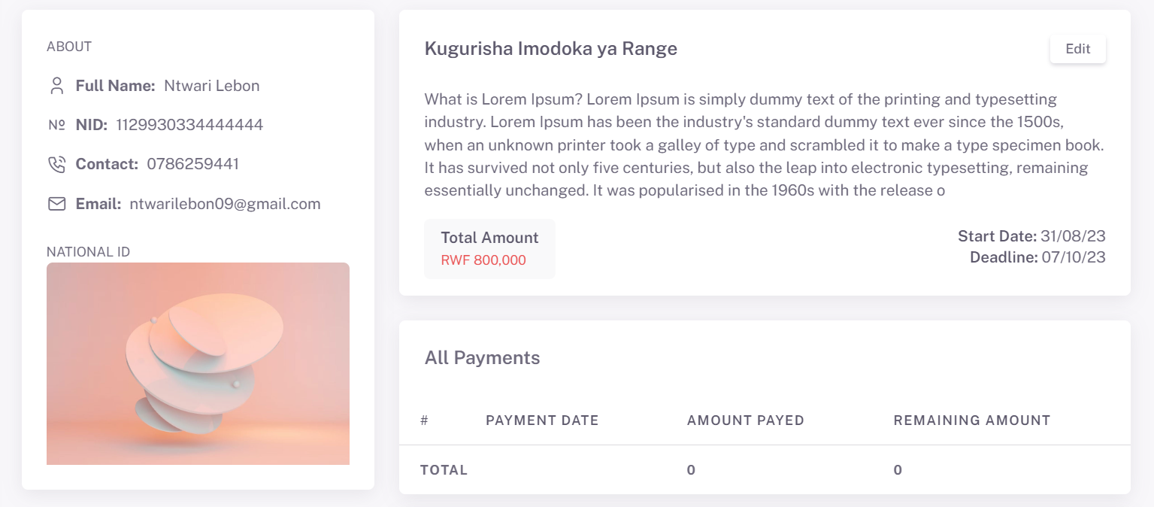

**Figure 16:agreement detail**

## Implementation and coding

### Introduction

After all phase have been perfectly done, the system will be implemented to the server and the system can be used.

### Description of implementation Tools and technology

**HTML**

Hypertext Markup Language (HTML) is the standard [markup language](https://en.wikipedia.org/wiki/Markup_language) for creating [web pages](https://en.wikipedia.org/wiki/Web_page) and [web applications](https://en.wikipedia.org/wiki/Web_application). With [Cascading Style Sheets](https://en.wikipedia.org/wiki/Cascading_Style_Sheets) (CSS) and [JavaScript](https://en.wikipedia.org/wiki/JavaScript), it forms a triad of [cornerstone](https://en.wikipedia.org/wiki/Cornerstone) technologies for the [World Wide Web](https://en.wikipedia.org/wiki/World_Wide_Web). Html version 3.2, 4.01, HTML, Html5. (Lerdorf, 1994)

**PHP**

PHP is a server-side scripting language designed for web development but also used as a general-purpose programming language. Originally created by RasmusLerdorf in 1994, the PHP reference implementation is now produced by The PHP Group. PHP originally stood for Personal Home Page, but it now stands for the recursive backronym PHP: Hypertext Preprocessor. (Lerdorf, 1994)

**MySQL**

MySQL is an [open-source](https://en.wikipedia.org/wiki/Open-source_software) [relational database management system](https://en.wikipedia.org/wiki/Relational_database_management_system) (RDBMS).

**JAVASCRIPT**

JavaScript, often abbreviated as JS, is a high-level, interpreted programming language that conforms to the ECMAScript specification. JavaScript has curly-bracket syntax, dynamic typing, prototype-based object-orientation, and first-class functions.

**CSS**

CSS is a language that describes a style of html documents. It is the language for describing the presentation of Web pages, including colors, layout, and fonts. It allows one to adapt the presentation to different types of devices, such as large screens, small screens, or printers.CSS2, CSS3.

### Screen Shots and Source Codes

Sample codes

@extends('layouts.app')

@section('title') Civilian Dashboard @endsection

@section('body')

<div class="row">

<!-- View sales -->

<div class="col-xl-4 mb-4 col-lg-5 col-12">

<div class="card">

<div class="d-flex align-items-end row">

<div class="col-7">

<div class="card-body text-nowrap">

<h5 class="card-title mb-0">Congratulations John! </h5>

<p class="mb-2">Best seller of the month</p>

<h4 class="text-primary mb-1">$48.9k</h4>

<a href="javascript:;" class="btn btn-primary waves-effect waves-light">View Sales</a>

</div>

</div>

<div class="col-5 text-center text-sm-left">

<div class="card-body pb-0 px-0 px-md-4">

<img src="../../assets/img/illustrations/card-advance-sale.png" height="140" alt="view sales">

</div>

</div>

</div>

</div>

</div>

<!-- View sales -->

<!-- Statistics -->

<div class="col-xl-8 mb-4 col-lg-7 col-12">

<div class="card h-100">

<div class="card-header">

<div class="d-flex justify-content-between mb-3">

<h5 class="card-title mb-0">Statistics</h5>

<small class="text-muted">Updated 1 month ago</small>

</div>

</div>

<div class="card-body">

<div class="row gy-3">

<div class="col-md-3 col-6">

<div class="d-flex align-items-center">

<div class="badge rounded-pill bg-label-primary me-3 p-2"><i

class="ti ti-chart-pie-2 ti-sm"></i></div>

<div class="card-info">

<h5 class="mb-0">230k</h5>

<small>Sales</small>

</div>

</div>

</div>

<div class="col-md-3 col-6">

<div class="d-flex align-items-center">

<div class="badge rounded-pill bg-label-info me-3 p-2"><i class="ti ti-users ti-sm"></i>

</div>

<div class="card-info">

<h5 class="mb-0">8.549k</h5>

<small>Customers</small>

</div>

</div>

</div>

<div class="col-md-3 col-6">

<div class="d-flex align-items-center">

<div class="badge rounded-pill bg-label-danger me-3 p-2"><i

class="ti ti-shopping-cart ti-sm"></i></div>

<div class="card-info">

<h5 class="mb-0">1.423k</h5>

<small>Products</small>

</div>

</div>

</div>

<div class="col-md-3 col-6">

<div class="d-flex align-items-center">

<div class="badge rounded-pill bg-label-success me-3 p-2"><i

class="ti ti-currency-dollar ti-sm"></i></div>

<div class="card-info">

<h5 class="mb-0">$9745</h5>

<small>Revenue</small>

</div>

</div>

</div>

</div>

</div>

</div>

</div>

<!--/ Statistics -->

</div>

@endsection

## Testing

### Introduction

**Testing** is a level of testing that validates the complete and fully integrated software product. The purpose of a system test is to evaluate the end-to-end system specifications. Usually, the software is only one element of a larger computer-based system. Ultimately, the software is interfaced with other software/hardware systems. System Testing is defined as a series of different tests whose sole purpose is to exercise the full computer-based system (guru99, 2022).

### Objective of Testing

The goal of system testing is to minimize the risks associated with the behavior of the system in a particular environment. For this, testers use the environment as close as possible to the one where a product will be installed after the release (u-tor, 2022).

1. Reducing risks, for bug-free components don’t always perform well as a system.
2. Preventing as many defects and critical bugs as possible by careful examination.
3. Verifying the conformance of design features, and performance with the specifications stated in the product requirements.
4. Validating the confidence in the system as a whole before moving to the final stage acceptance testing that takes place right before users get access to a product (u-tor, 2022).

### Unit testing outputs

Unit testing is a method by which individual units of [source code](http://en.wikipedia.org/wiki/Source_code), sets of one or more computer program modules together with associated control data, usage procedures, and operating procedures, are tested to determine if they are fit for use

The primary goal of unit testing is to take the smallest piece of testable software in the application, isolate it from the remainder of the code, and determine whether it behaves exactly as you expect. Each unit is tested separately before integrating them into modules to test the interfaces between modules. Unit testing has proven its value in that a large percentage of defects are identified during its use.

The goal of unit testing is to isolate each part of the program and show that the individual parts are correct. A unit test provides a strict, written contract that the piece of code must satisfy. As a result, it affords several benefits.

### Validation testing outputs

Defines validation testing as an activity that ensures that an end product stakeholder’s true needs and expectations are met (browserstack, 2022).

Validation Testing ensures that the product actually meets the client's needs. It can also be defined as to demonstrate that the product fulfills its intended use when deployed on appropriate environment (Qayyum, 2020).

### Integration Testing Outputs

Integration testing -- also known as integration and testing (I&T) -- is a type of [­software testing](https://www.techtarget.com/whatis/definition/software-testing) ­­­in which the different units, modules or components of a software application are tested as a combined entity (Awati, 2022).

You can do integration testing in a variety of ways but the following are three common strategi­­­es:

* **Bottom up Testing** is an approach to integrated testing where the lowest level components are tested first, then used to facilitate the testing of higher-level components. The process is repeated until the component at the top of the hierarchy is tested. All the bottom or low-level modules, procedures or functions are integrated and then tested. After the integration testing of lower-level integrated modules, the next level of modules will be formed and can be used for integration testing. This approach is helpful only when all or most of the modules of the same development level are ready. This method also helps to determine the levels of software developed and makes it easier to report testing progress in the form of a percentage.
* **Top down Testing** is an approach to integrated testing where the top integrated modules are tested and the branch of the module is tested systematically until the end of the related module.
* **The third approach**, sometimes referred to as the umbrella approach, requires testing along functional data and control-flow paths. First, the inputs for functions are integrated in the bottom-up pattern discussed above. The outputs for each function are then integrated in the top-down manner. The primary advantage of this approach is the degree of support for early release of limited functionality. It also helps minimize the need for stubs and drivers. The potential weaknesses of this approach are significant, however, in that it can be less systematic than the other two approaches, leading to the need for more regression testing.

### Functional and system testing Results

**FUNCTIONAL TESTING** is a type of software testing that validates the software system against the functional requirements/specifications. The purpose of Functional tests is to test each function of the software application, by providing appropriate input, verifying the output against the Functional requirements (Hamilton, 2022).

Functional testing mainly involves black box testing and it is not concerned about the source code of the application. This testing checks User Interface, APIs, Database, Security, Client/Server communication and other functionality of the Application under Test. The testing can be done either manually or using automation (Hamilton, 2022).

### Acceptance Testing Report

Acceptance testing, in the context of the engineering and software industries, is a functional trial performed on a product or prototype before it is put on the market or delivered, to decide whether the specifications or contract have been met. It also makes sure the quality and design of the product meet both contractual and regulatory obligations in terms of functionality, usability, durability, and safety (HAYES, 2022).

# CONCLUSIONS AND RECOMMANDATION

## INTRODUCTION

The system is “**civil agreement management system**” this is an interactive web application-based system for notaryin which it is used as a tool for notary and citizen to create, manage and store agreement. The system interface is easy to use owing to well organized situations on the system with just the easy steps on the entering on the system are well Cleary presented to all users of the system.

As the system will allow the citizen the way of create, manage and store agreement where notary will be the one to register notary and after register citizen. citizen will login using password and username after that citizen will create agreement and after creating agreement second party will receive request and if second party accept request it will be like signing on agreement and citizen also can denial request. notary will be allowed to view agreement detail and citizen detail.

Administrator of the system is the one who will be the one to register notary, view agreement detail and also can view citizen detail.

## Conclusion

By accomplishing this project about smartening and digitalizing civil agreement management system, that will be a competitive way GISOZI SECTOR with another sector.

This project accomplishment will leave me bright skills in web designing as where web application can work instantaneously with smartphone while notifying admin and citizen from every agreement status for easier communication.

As the owner, I will much benefit from it by earning money as the GISOZI SECTOR had already been excited with-it functionality.

The project will also benefit the GISOZI sector where it will be facilitating the agreement detail system faster, accuracy and more efficient performance.

In analyzing, designing, implementing, and maintaining standards, we considered these characteristics as the foundation. These standards were made national. Civil Agreement Management System will be an inexpensive and less time-consuming method once a system exhibiting national standards and the above-mentioned characteristics is implemented.

## Recommendation

After my research and my finalization of this project,

I highly recommend Gisozi sector to put this system in use where will be easier for citizen to create agreement and it will also easier to store those agreement in case, they fail to do what is in agreement court can use those stored agreement as evidence which will be easier and fast to solve those conflict.

I recommend the future researchers to improve this project, to add more functionality that can help the user of this system, they should also improve the interface so that it looks more interesting to the user, and the other researchers should also use new advanced software in order to enhance the security of this system because for us some objectives have not well achieved caused by short Time and lack of funds for completing what I was supposed to implement.

BIBLIOGRAPHY

Akhtar, I. (2016). Research Design. In M. I. Akhtar, *Research Design* (pp. 10-15). 2016.

Angrosino, M. (2007). *Doing Ethnographic and Observational Research.* SAGE Publication Ltd.

Angrosino, M. (2007). *Doing Ethnographic and Observational Research.* SAGE Publications Ltd.

angrosino, m. (2007). *Doing Ethnographical observational and research.* SAGE PUBLICATIONS.

Angrosino, m. (2007). *Doing Ethnographical observational and research.* SAGE Publication Ltd.

Angrosino, M. (2007). *hhh.* SAGE Publications Ltd.

ashirwadam, j. (2014). *communication and data analysis.*

Awati, R. (2022). *https://www.techtarget.com/*.

*browserstack*. (2022).

Burback, R. (1998). 120-125.

Clark, W. (1967,April). *System.* 1967.

derclaye, E. (2005). *what is database.*

ern, A. t. (2019). *web applications.*

fox, n. (2009). *Using Interviews in a research project.* Radcliffe Medical Press.

gazette, o. (2011). *law governing contracts.* kigali.

*guru99*. (2022).

Hamilton, T. (2022). *guru99*.

HAYES, A. (2022). *investopedia*.

kingdom, u. (2020). *agreement.* APS Group.

lee, D. j.-t. (2019, november). creation of contract. *contract law in singapore*, pp. 4-6.

Lerdorf, R. (1994, may 12). Retrieved may 14, 1994, from https://www.webcodegeeks.com/

Limited, T. P. (2019, november 4). *SDLC - Waterfall Model*. Retrieved from tutorialspoint: https://www.tutorialspoint.com/sdlc/sdlc_waterfall_model.htm

*lucidchart*. (2022).

Qayyum, A. (2020). *tutorialspoint*.

state, i. s. (2019). *indiana notary public guide.* lulu press.

Tom. (2021). *statisticssolutions*.

upcounsel. (n.d.). *Civil Agreement Contract: Everything You Need to Know*. Retrieved from upcounsel: https://www.upcounsel.com/civil-agreement-contract#:~:text=A%20civil%20agreement%20contract%20is,civil%20courts%20handle%20these%20contracts.

*u-tor*. (2022). Retrieved from https://u-tor.com/topic/system-testing#:~:text=The%20goal%20of%20system%20testing,be%20installed%20after%20the%20release.

wikipedia. (2023, march 18). *Internet research*. Retrieved from Wikipedia, the free encyclopedia: https://en.wikipedia.org/wiki/Internet_research